Waves: the **mechanical expression of energy**

1. **Identify key properties of waves**

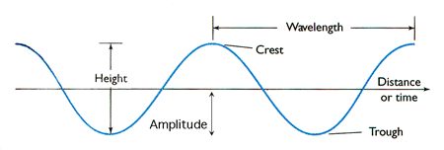

|  |  |  |
| --- | --- | --- |
| Crest | - | highest point of a wave |
| Trough | - | lowest point of a wave |
| Wavelength | ***L*** or λ | distance between two successive crests or two successive troughs of a wave; (metres) |
| Wave Height | ***H*** | vertical distance between crest and trough; (metres) |
| Amplitude | ***a*** | ***H*** ÷ 2; (metres) |
| Period | ***T*** | time for one wavelength to pass a point; (minutes or seconds) |
| Frequency | ***f*** | number of waves passing a point per unit of time; (per minute or second) |
| Celerity or Speed | ***S*** | distance traveled per unit time; (metre per second) |
| Steepness | - | a measure of the "peakedness" of a wave; the ratio of Height to Wavelength, ***H*** / ***L***; (no units) |

1. **Use these properties to determine wave speed and behavior in either shallow or deep water**

The speed of a wave is affected by the environment it travels through. The speed of deep-water waves is controlled by its wavelength. As a wave enters into the shallow water environment, its speed becomes dependent on the depth of the water it is traveling through.

**Deep-water waves** are also called **dispersive** waves because the speed of travel is related to their wavelength (distance from crest to crest). In other words, waves with longer wavelengths travel faster than short waves. Equa. **S = sqrt(g*L/2pi)** where L is the wavelength, S = 1.56T where T is the period of the wave in seconds

A **shallow-water wave** is called **non-dispersive** because its wave speed is controlled only by the depth of the water. This means that **all** shallow-water waves, regardless of length, travel at the **same** speed when they are at the same depth. Equa**. S = 3.1 * sqrt(d)** where d is the depth of the water in metres

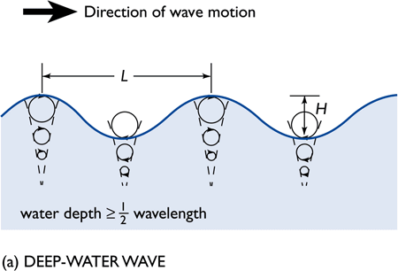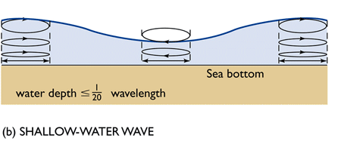

* 1. **Deep-water waves.** Deep-water waves are waves that are traveling in ocean depths **d** equal or deeper than **L** ÷ 2 (see figure and table below). These waves do not "feel the bottom" because their wave bases are shallower than the ocean bottom.
  2. **Shallow-water waves.** Shallow-water waves are waves that are traveling in shallow water relative to their wavelengths, that is, where the water depth **d** is equal or shallower than **L** ÷ 20. These waves are said to "feel the bottom" as the water particles are dragging on the bottom as they move.

1. **Explain how waves move matter and energy**

The ocean surface is intimately linked with the atmosphere. Winds drive the surface circulation of oceanic water. When wind blows over the ocean, it drags on the surface and transfers energy from the atmosphere to the water, thus creating waves and currents.

Very large scale, permanent winds that blow over the ocean produce **surface currents**, which transport both matter (water) and energy.

Winds that blow occasionally or over smaller areas produce **waves**, which transport energy in the direction of the wind. Technically, we define waves as the **mechanical expression of energy**.

1. **Describe the forces that generate waves, eliminate waves, and return the ocean to a flat, undisturbed surface**

|  |  |  |
| --- | --- | --- |
| **GENERATING FORCE** | **WAVE TYPE** | **TYPICAL WAVELENGTH** |
| Wind over ocean | Wind Wave | 60 - 150 m (200 - 500 ft) |
| Changes in atmospheric pressure; Storm surge; Tsunami | Seiche | large, variable; a fraction of basin size |
| Faulting of sea floor; Volcanic eruption; Landslide | Tsunami | 200 km (125 mi) |
| Gravitational attraction; Rotation of Earth | Tide | ½ circumference of Earth, 20,000 km (12,500 mi) |

Wind-generated waves are the most familiar in our image of the ocean and are in fact the most common waves in the ocean. Wind blows over the ocean constantly but can range in strength, amount of time blowing over the ocean, and the area it blows over. Thus, wind-generated waves can range from very tiny wrinkles on the surface of the ocean, gently rolling waves, to giant waves that can break ships in two.

The next two wave types, seiches and tsunami, are generated by forces that occur episodically.

|  |  |  |
| --- | --- | --- |
| **RESTORING FORCE** | **WAVE TYPE** | **TYPICAL WAVELENGTH** |
| Surface tension | Capillary Wave | < 1.7 cm (¾ in) |
| Gravity | Surface Gravity Waves: (Wind Wave, Seiche, Tsunami, Tide) | > 1.7 cm |

**Restoring force**: force that causes water to return to its undisturbed state

Capillary waves are tiny waves with wavelengths about the size of your fingernail. These waves are restored by surface tension. When wind blows over a calm sea, these waves are generated first.

As the wind continues, more energy is transferred to the ocean surface and the waves grow into those that can only be restored by gravity.

1. **Explain the factors that determine the roughness of the sea**

To reiterate, the condition of the surface ocean, or its **sea state** depends on three factors:

* Wind strength/speed
* Fetch
* and Wind duration, the length of time that the wind has been blowing over the fetch

The amount of energy transferred to the ocean can be estimated by the height of the waves produced. Thus, when the ocean has very tall waves, it means that lots of energy have been transferred to it. These very large waves are formed when the wind speed is very high. In addition, this wind must blow for a long period of time over an uninterrupted distance in the same direction in order to generate these large waves. We call that uninterrupted distance or area the "fetch". Of course, the waves in the ocean will not ever be uniformly equal. There will always be a range of various wave heights, lengths, and speed.

1. **Describe how waves interact; explain constructive and destructive interference**

Waves don't usually reflect (bounce back) when they strike other waves. Instead, they combine or are superpositioned, either constructively or destructively.

**Constructive interference** occurs when the wave amplitudes (half the vertical distance between a trough a crest) reinforce each other, building a wave of even greater amplitude, i.e. bigger waves.

**Destructive interference** occurs when the wave amplitudes oppose each other, resulting in waves of reduced amplitude, namely smaller waves.

1. **Describe wave refraction, seiche (standing waves in enclosed or semi-enclosed bodies), and resonance; how do these affect the coast and people?**

**Wave Refraction**.

Waves usually approach a shore at an angle, rarely head-on or at a perfect right angle (90°). Because waves slow down as the depth becomes shallower, the segment of the wave that is closest to shore will be "feeling the bottom" and slowing down before the rest of the wave that is farther out.

This results in the **refraction** or bending of the wave, allowing it to be nearly parallel to the shore as it approaches.

Wave refraction is closely associated with an important process occurring in most coastlines -- **shore straightening**. The waves are in fact refracting as they hit an irregular coast causing wave energy to **focus** on headlands, and **disperse** (spreads out) across bays. Thus over time the shoreline straightens out as waves **erodes** sediments from headlands and **deposits** these in bays.

1. **Relate wave interference and resonance to marine hazards**

Every enclosed body of water has a natural resonance. A **seiche** (pronounced saysh) is a resonant wave in a body of water caused by a disturbance by wind or seismic activity. The water sloshes back and forth within the water body, with the wave racing between opposing shores. Seiches commonly form in lakes or landlocked seas but can also form in semi-enclosed seas.

In a few of the tsunami case studies discussed, seiches were observed to be generated when a tsunami entered a semi-enclosed body. Hilo Bay in Hawaii, has been identified as a location that is critically vulnerable to damaging effects from a tsunami because the Bay has a resonance that is a factor of the tsunami period. Historically, the tsunami damage suffered by the residents of Hilo has been a combination of the effects of the tsunami and the tsunami-generated seiche.

1. **Describe how tsunami form and how they are detected**

Large displacements of oceanic water can be caused by:

* Earthquakes (vertical submarine fault motion)
* Volcanic eruptions
* Landslides into the ocean
* Icebergs falling from glaciers
* Meteor impacts

Here is how the **Pacific Tsunami Warning and Mitigation System (PTWS)** works:

1. an earthquake of sufficient size to trigger the alarms, set at the threshold of 6.5 on the Richter Scale, is detected
2. seismic data is collected, the earthquake is located, and its magnitude is computed
3. reports from tide stations are monitored for any indication that a tsunami has been generated, i.e., anomalous changes in wave height other than that from tides
4. if so, a warning is transmitted to the participating agencies (dissemination points) for relaying to the public
5. predetermined plans to evacuate people from endangered areas are implemented

The [DART®](http://nctr.pmel.noaa.gov/Dart/index.html) (Deep-ocean Assessment and Reporting of Tsunamis, see figure below) is a real-time tsunami monitoring system consisting of "**tsunameters**" (monitoring devices) and buoys positioned at strategic locations throughout the world's ocean. The tsunameter is a seafloor bottom pressure recording (BPR) system capable of detecting tsunami as small as 1 cm (wave height in the middle of the ocean). The data generated by the bottom meters are transmitted to the moored surface buoy which then sends the data to various Warning Centers via real-time communications.

1. **Explain how a tsunami compares with other ocean waves**

hundreds of kilometres in wavelength for tsunami versus metres to 100's of metres for common waves; minutes to an hour in period for tsunami versus seconds for common waves.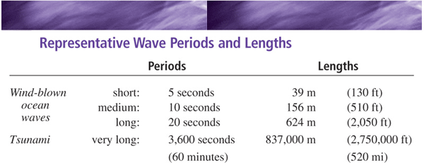

1. **Discuss why tsunami come ashore so violently**

Destruction from a tsunami is not due to the high waves crashing down but due to the **momentum (speed and mass) of the large mass of water** and the **ultra long wavelength and period**

Figure WA.37 (top) Wind-driven waves coming to shore have relatively short wavelengths and periods; wave breakers arrive and recede quickly. (bottom) Tsunami arriving ashore have ultra long wavelengths and periods. A huge mass of water (a wall of water) comes onshore for several minutes! 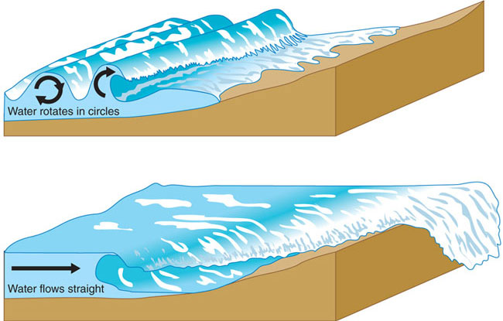

1. **Identify tsunami warning signs, and know how to respond**

**Tsunami Safety Rules**

* A strong earthquake felt in a low-lying coastal area is a natural warning of possible, immediate danger.  
  **Keep calm and quickly move to higher ground away from the coast**.
* When you hear that an earthquake has occurred in the ocean or coastline regions, prepare for a tsunami emergency.
* Be aware that tsunami can occur at any time, day or night and that they can travel up rivers and streams that lead to the ocean.
* A tsunami is not a single wave, but a series of waves. Stay out of danger until an "ALL CLEAR" is issued by a competent authority.
* Approaching tsunami are sometimes heralded by noticeable rise or fall of coastal waters. This is nature's tsunami warning and should be heeded.
* Approaching large tsunami are usually accompanied by a loud roar that sounds like a train or aircraft. If a tsunami arrives at night when you cannot see the ocean, this is also nature's tsunami warning and should be heeded.
* A small tsunami at one beach can be a giant a few kilometres away. Do not let modest size of one make you lose respect for all.
* Sooner or later, tsunami visit every coastline in the Pacific. All tsunami - like hurricanes - are potentially dangerous even though they may not damage every coastline they strike.
* Never go down to the beach to watch for a tsunami!  
  **WHEN YOU CAN SEE THE WAVE, YOU ARE TOO CLOSE TO ESCAPE.**  
  Tsunami travel faster than a person can run!
* During a tsunami emergency, your local emergency management office, police, fire, and other emergency organizations will try to save your life. Give them your fullest cooperation.
* Homes and other buildings located in low-lying coastal areas **are not safe**. Do NOT stay in such buildings if there is a tsunami warning.
* The upper floors of high, multi-story, reinforced concrete hotels can provide refuge (vertical evacuation) if there is no time to quickly move inland or to higher ground.
* If you are on a boat or ship and there is time, move your vessel to deeper water (at least 2,000 metres). If there is concurrent severe weather, it may be safer to leave the boat at the pier and physically move to higher ground.
* Stay tuned to your local radio, marine radio, Weather Radio, or television stations during a tsunami emergency. Bulletins issued through your local emergency management office and National Weather Service offices can save your life.

1. **Describe the risks from a tsunami for the coast of British Columbia, especially one resulting from a megathrust earthquake.**

Residents at high-risk areas must be aware that a strong near-shore earthquake may generate a **local tsunami**. Therefore, it is highly recommended those in these areas move inland or to high ground immediately as soon as they feel strong ground shaking. Emergency officials **may not have time** to issue a warning.

1. **Describe how storm surges are generated**

A **storm surge** is an abrupt bulge of water driven ashore by a hurricane. It is generated by 2 processes occurring at the same time: a) Hurricane winds pushing water into a large/tall mound called the **wind-driven surge**; b) Raising of ocean water (literally suctioned upwards) underneath the eye of storm because of low air pressure at the ocean surface; this second process produces a smaller effect. The effect of air pressure is called a **pressure surge**.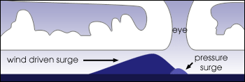

1. **Identify where and how the maximum surge occur in a hurricane**

As shown in the schematic diagram above, the coastal area to the right of the storm (in the Northern Hemisphere, as you face the shoreline) experiences the severest force of the surge. This is because the **wind-driven surge is in the same direction (onshore) as the pressure surge**. On the left side of the storm, the winds are directed away from land (offshore) thus the force of the storm surge on land is at a minimum.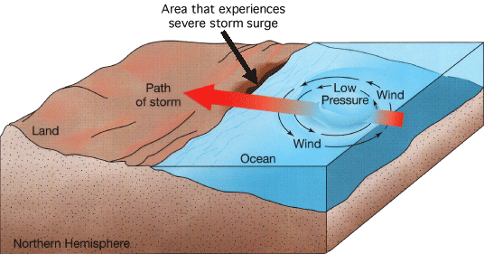

1. **Define wave breaking and determine when a wave will break**

**Breaking Waves**. We learned earlier that as a **swell** reaches the coast, its steepness increases to a point where **H / L** (the ratio of wave height to wavelength) nears the value of **1 / 7**. At the same time, the ratio of the wave height to the depth of the water, **H / d** also approaches a value of **3 / 4**. Beyond these critical points, the wave crests become unstable and the wave **breaks**. Whitecaps (froth) begin to form as the wave has turned to **surf**, the turbulent mass of agitated water rushing onshore.

When a wave breaks, its energy is dissipated in the surf zone and transformed into kinetic energy, affecting both the water and land, including the ocean bottom and the shore.

1. **Explain differences between surging, plunging, and spilling breakers**

The shape, size, and behaviour of the breaking wave is controlled by the slope of the ocean bottom (see accompanying figures):

* Areas where the ocean bottom is **flat** or **gentle** produce spilling breakers; spilling breakers release their energy over a wide area. These "waves" are good for (safe) surfing!
* Areas with **moderately steep** ocean bottoms produce **plunging** breakers. These waves are for expert surfers only!
* Areas where the ocean bottom is **very steep** produce **surging** breakers. These breakers release their energy in sudden bursts, making them potentially dangerous. Much of the wave energy is reflected back into water.

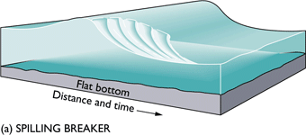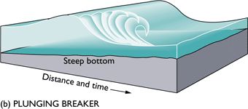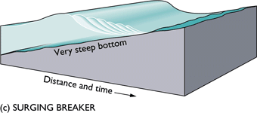

1. **Predict the type of breaking wave that will be found on a given beach**

Although the **type** of breaking waves expected at a specific beach does not change, surf **varies on a daily basis**. This variation is dictated by the parameters of the waves that arrive on shore, mainly wavelength, wave height, and wave energy. These we have learned in previous sections are affected by the following variables:

* swell from distant storms
* local wind that may interfere with the waves generated much farther off shore
* constructive or destructive interference from other swells

1. **Describe how coastlines affect waves, and how waves affect coastlines**
2. **Compare and contrast the effects of artificial barriers such as groins, seawalls, and other structures, on coastal processes**

1. **Groins**. Elongate structures that protrude perpendicular to the shoreline. These structures have been proven to be quite successful in trapping and retaining sediments on the up-drift side (that facing the wave front)

What is not realized is that groins interfere with longshore transport of sediments such that deposition and erosion occurs in unexpected places: deposition in the up-drift (upstream) side and erosion in the down-drift (downstream) side. 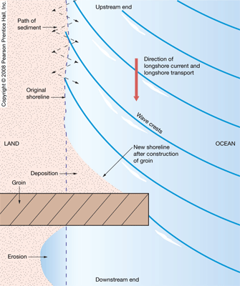

2. **A jetty** is built to protect an inlet or harbour. Longshore drift naturally moves inlets over time -- one fills in, another opens. Jetties limit this, locking the inlet in place. Often built in pairs, one on each side of an inlet, they interfere with longshore drift in a manner similar to groins -- accretion on updrift side, erosion on downdrift side.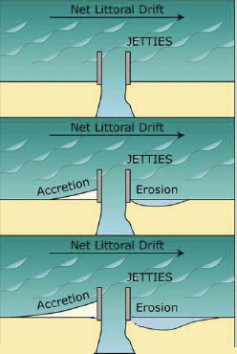

3. **A breakwater** is another type of protective structure built to defend against wave action and erosion. These structures are built at a distance away from the coast being protected. As waves hit a breakwater, their energy is dissipated onto the structure. The area behind the breakwater becomes a safe harbour for boats and ships as they are protected from the pitching and rolling effects from waves.

In addition, the coastline behind a breakwater is protected from the erosive action of waves. Because the waters are calm, deposition occurs and beaches build up behind the breakwater (see figure below). However, because the breakwater cuts off the energy required to drive the longshore transport, adjacent unprotected sections of the coastline do not receive fresh supplies of sediments and gradually shrink due to erosion.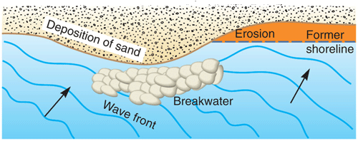

4. **A tethered-float breakwater** is an innovative variation of the standard breakwater. This system has the advantage over traditional structures of removing energy from waves **without** interfering with sediment transport along the shore. The system consists of 1.5-metre spheres of steel placed 1.5 m apart. The spheres are anchored to the ocean floor and held just beneath the ocean surface.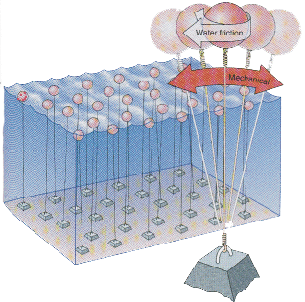

5. **A seawall** is another form of coastal defense to reduce the effects of strong waves and to defend the coast around a town or harbour from erosion. In contrast to groins and breakwaters, which are built on the seaward side of the coastline, seawalls are constructed on the inland part of a coast. The walls are constructed to **reflect** wave power and can be sloping, vertical or curved.

Rather than protecting the beach, seawalls ultimately promote increased erosion and destruction of beaches. 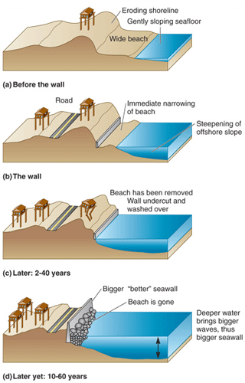

1. **Relate these changes to risks for coastal communities**

The Stanley Park Seawall is a very good example of the good and bad effects of seawalls. This seawall is an effective defense in the short-term (years to a few decades) as it reflects the wave energy off the protected coastline (photo in left panel below). However, it has caused increased erosion in the long-term (many decades). The energy of the backwash is reflected off the beach material beneath and in front of the seawall, so the beach material is gradually eroded (photo in right panel below). The seawall will eventually collapse when the sediment foundation it is built on becomes fully eroded.

